CSA1509-Cloud computing and Big Data Analytics
Name : P Preethi
Reg.no: 192521178

EXP 14 : Create a Virtual Machine with 1 CPU, 2GB RAM and 15GB storage disk using a Type 2 Virtualization Software.
Aim:
To create a VM with:
- No of processor : 1
- Memory : 2 GB
- Hard disk : 15 GB
Steps:
- Download VMware software and install it as Type-2 Hypervisor.
- Download Ubuntu or tiny os as ISO image file.
- In VMware workstation Create new VM
- Do the configuration based on given conditions.
- Created a virtual Machine .
- Launch the VM.

Implementation:
- Download and open VMware software.
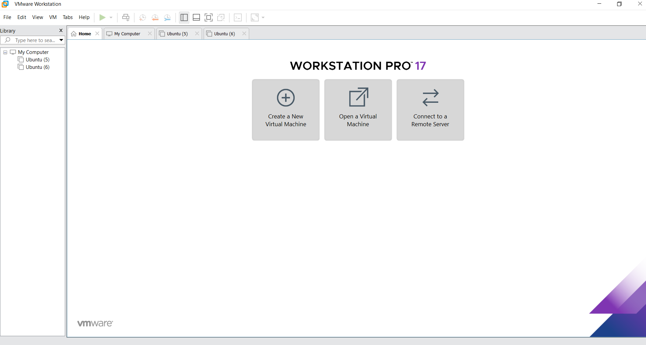
2.Create a new VM

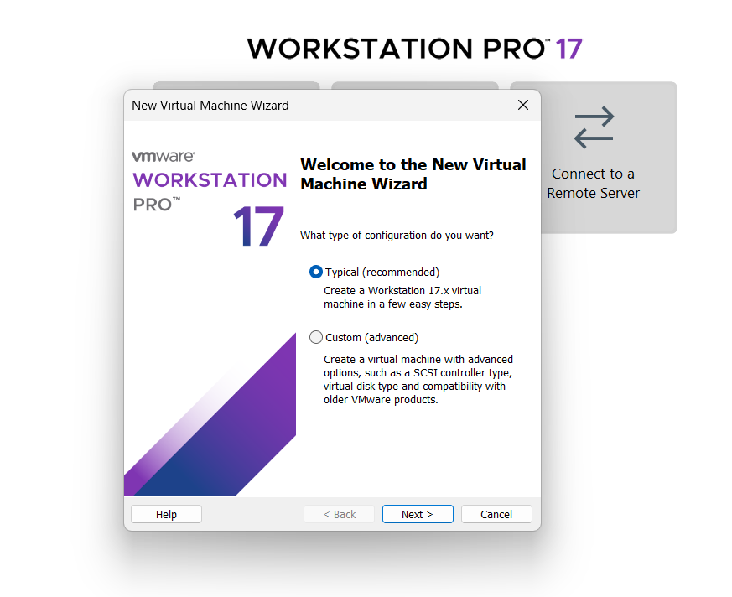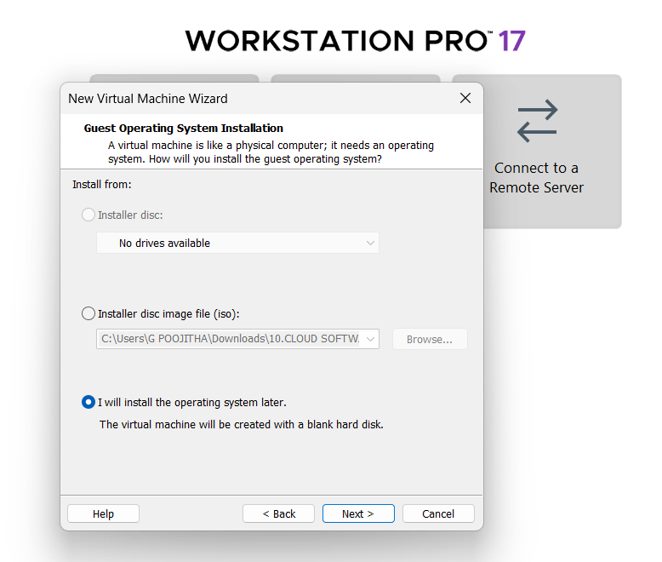
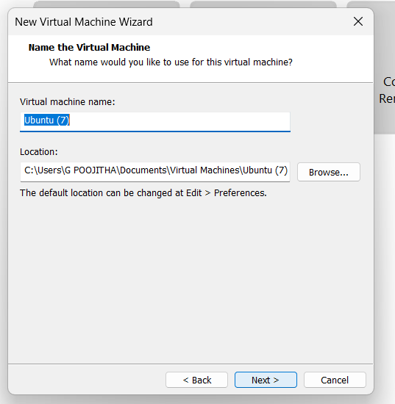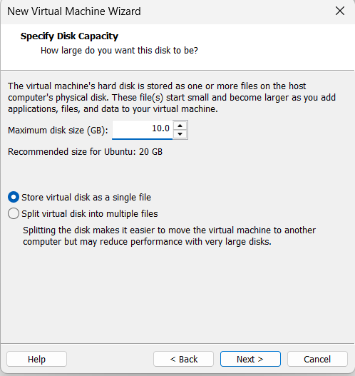
Name it anythingclick on nextAdjust the size of disk change the option to first and then click on next.
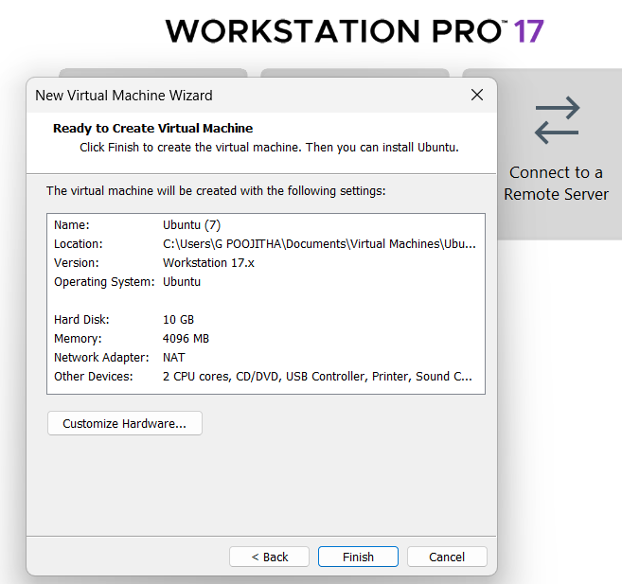 Click on Finish to Launch .
3.VM is created
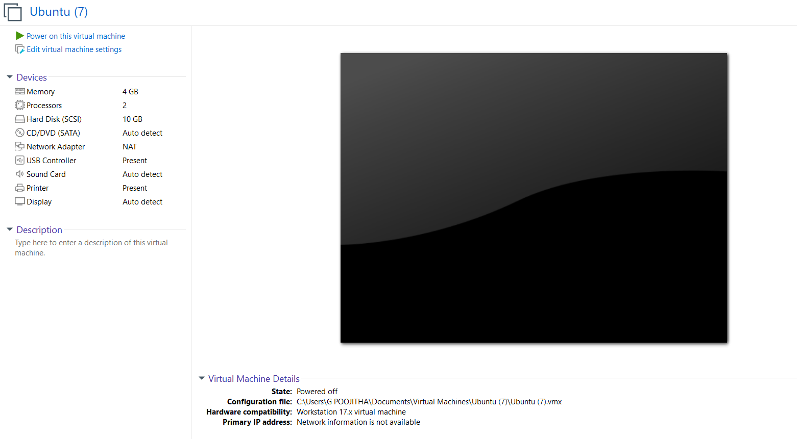

4. we can customize the configuration of hard disk while crearing VM and can add additional hard disk later if needed

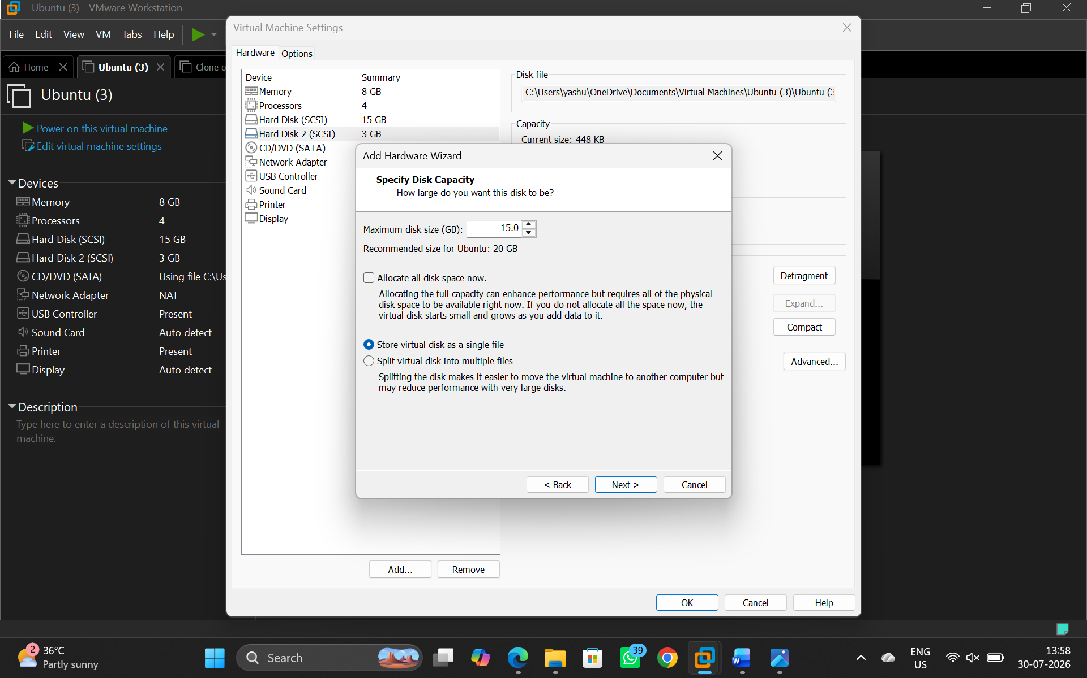

5.Double click on the processor and set it to given configuration
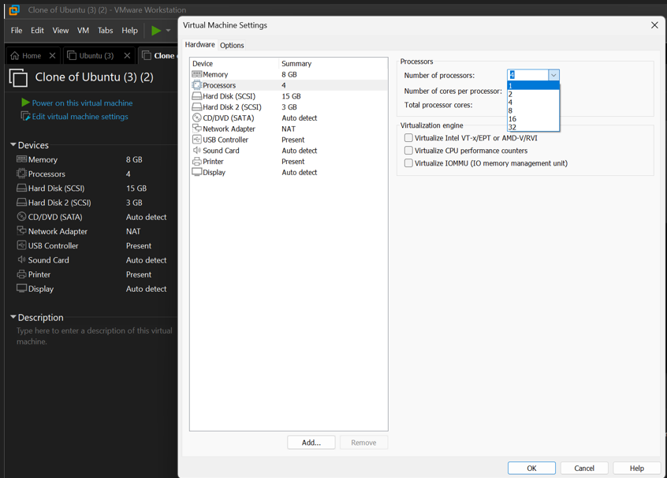

- Double click on the ram to customize the desired storage
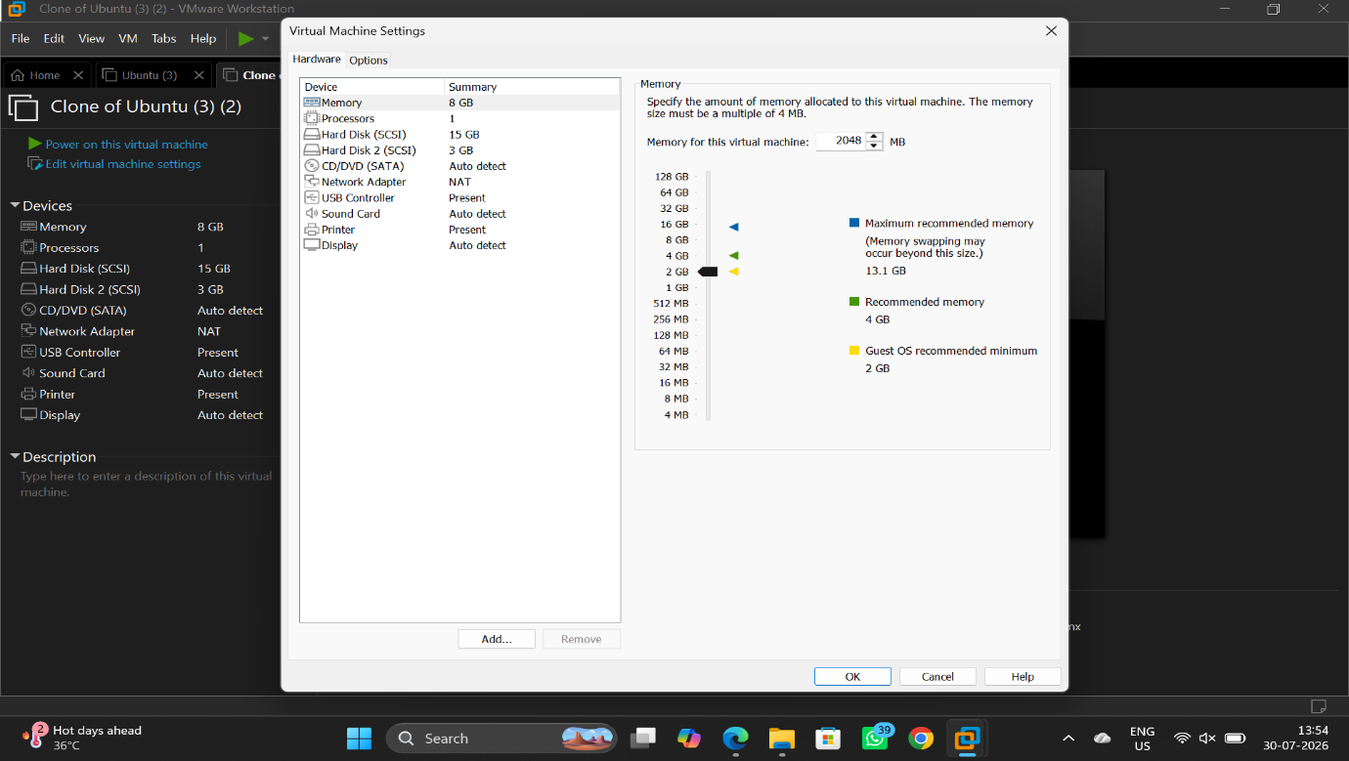

8.VM with given configuration
